**Project Title:**

Towards a Secure Hierarchical RBAC Application with Blockchain Integration for Smart Manufacturing in the Industrial Internet of Things (IIoT)

# Abstract

The project "Towards a Secure RBAC Application with Blockchain Integration for Smart Manufacturing in the Industrial Internet of Things (IIoT)" takes a novel method to improving security in IIoT-enabled smart manufacturing systems. By developing and implementing a customised Role-Based Access Control (RBAC) architecture, it fulfils the fundamental need for robust access control in these situations. The project's uniqueness stems from the incorporation of blockchain technology with RBAC, which provides a decentralised, tamper-resistant framework for controlling access permissions.

The system defines unique roles such as User, Administrator, and Device, each with their own set of access permissions, ensuring a safe and efficient operational environment. This method is especially important in the context of IIoT, where various devices and people interact in real time. The project also includes a simulation of these interactions within the RBAC-enabled IIoT ecosystem, which uses blockchain to secure access control processes.

The project's emphasis on ensuring security, privacy, and data integrity within the framework of smart manufacturing is crucial. The use of blockchain in RBAC not only improves security but also adds transparency and traceability to access control activities. This is especially important in production environments where data reliability and system integrity are critical.

Overall, this project represents a substantial advancement in IIoT security by providing a scalable, safe, and effective approach for controlling access control in smart industrial systems. Its revolutionary combination of RBAC and blockchain technology establishes an entirely novel safety standard in the fast-developing field of industrial automation and IIoT.

Table of Contents

Abstract 2

Section 1: Introduction 3

1.1 Research Motivation 3

1.2 Research Contribution 3

1.3 Research Questions 3

1.4 Structure of the Thesis 4

Section 2: Literature Review 5

2.1 Background 5

2.2 Related Works 5

2.3 Access Control Models 5

2.4 IIoT Applications 5

2.5 Blockchain Concept 6

Section 3: Research Methodology 7

3.1 Methodological Approach 7

3.2 Flow Diagram 8

Section 4: System Design and Development 10

4.1 RBAC System Design 10

4.2 Blockchain Integration 10

4.3 Mathematical Representation of RBAC 10

Section 5: Testing, Results, and Evaluation 11

5.1 Testing Methodology 11

5.2 Results 11

5.3 Evaluation 11

Section 6: Future Work 12

6.1 Potential Enhancements 12

6.2 Future Research Directions 12

Section 7: Conclusion 13

7.1 Summary of Findings 13

7.2 Implications 13

7.3 Final Thoughts 13

# Section 1: Introduction

## 1.1 Research Motivation

In the rapidly evolving landscape of the Industrial Internet of Things (IIoT), smart manufacturing has emerged as a pivotal domain, leveraging interconnected technologies to revolutionize production processes. However, this integration of cyber-physical systems also introduces complex security challenges. The need to protect sensitive data and maintain operational integrity is paramount, given the potential risks of unauthorized access and data breaches. Traditional access control models, while foundational, often fall short in addressing the dynamic and decentralized nature of IIoT environments. These models, including the widely-adopted Role-Based Access Control (RBAC), are now at a crossroads, requiring a reevaluation and enhancement to meet the security demands of contemporary smart manufacturing systems.

## 1.2 Research Contribution

This research project seeks to fortify the RBAC model within the context of IIoT for smart manufacturing. By integrating blockchain technology, a novel approach is proposed to not only reinforce the security framework but also introduce a new level of decentralization and transparency. This integration aims to address inherent limitations in conventional RBAC systems by leveraging blockchain's immutable and distributed ledger characteristics. The anticipated outcome of this project is a more robust, tamper-resistant, and scalable access control mechanism. This enhancement is expected to significantly elevate the security posture, ensuring data integrity and reliable access management in smart manufacturing environments.

## 1.3 Research Questions

The research is guided by two pivotal questions:

**What are the inherent limitations of the current RBAC models when applied within the IIoT framework, particularly in smart manufacturing scenarios?** This question aims to dissect the existing RBAC framework, identifying gaps and vulnerabilities that could be exploited in the context of IIoT.

**How can blockchain technology be effectively integrated into the RBAC model to enhance its security and integrity within smart manufacturing environments?** This question explores the potential of blockchain as a complementary technology to RBAC, aiming to understand how its features can be harnessed to mitigate identified limitations and improve overall system security.

## 1.4 Structure of the Thesis

The thesis is organized into several key sections to systematically address the research questions and objectives:

**Section 2:** Literature Review delves into the existing body of work surrounding RBAC, IIoT applications, and blockchain technology, setting the stage for the proposed enhancements.

**Section 3:** Research Methodology outlines the methods employed in this study, including theoretical analysis and practical experimentation, complemented by a flow diagram for clarity.

**Section 4:** System Design and Development details the architectural design of the enhanced RBAC model, its blockchain integration, and the mathematical foundations underpinning the system.

**Section 5:** Testing, Results, and Evaluation presents the empirical testing of the developed system, analyzes the results, and evaluates them against the research objectives.

**Section 6:** Future Work suggests potential areas for further research and enhancements to the proposed system.

**Section 7:** Conclusion summarizes the findings, discusses the implications of the research, and reflects on the study's contributions to the field of IIoT security.

This structured approach ensures a comprehensive exploration and presentation of the research, aiming to contribute significantly to the fields of IIoT security and access control.

# Section 2: Literature Review

## 2.1 Background

The Industrial Internet of Things (IIoT) represents a transformative shift in smart manufacturing, integrating advanced digital technologies into industrial processes. By harnessing IoT, smart manufacturing leverages interconnected devices and systems to enhance operational efficiency, reduce downtime, and improve product quality. The IIoT ecosystem encompasses a range of technologies including sensors, network connectivity, data analytics, and automation tools, which collectively contribute to the creation of intelligent, self-optimizing manufacturing processes. The importance of IIoT in smart manufacturing lies in its ability to provide real-time data, facilitate predictive maintenance, and enable flexible production lines, thereby revolutionizing traditional manufacturing paradigms.

## 2.2 Related Works

Existing literature provides a comprehensive understanding of RBAC, its applications in various domains, and its evolution in the context of IIoT. Scholars have explored the adaptability of RBAC in dynamic environments like IIoT, assessing its flexibility and scalability. In the realm of blockchain, studies have focused on its disruptive potential across industries, including its emerging role in securing IoT networks. The intersection of RBAC and blockchain in IIoT is a relatively novel area, with research emphasizing the need for decentralized and robust security solutions in complex IoT ecosystems.

## 2.3 Access Control Models

Access control models are fundamental to securing information systems. The most prevalent models include Discretionary Access Control (DAC), Mandatory Access Control (MAC), and Role-Based Access Control (RBAC). RBAC, in particular, stands out for its efficiency in managing user permissions based on roles within an organization, simplifying the administration of access rights. The model's relevance in IIoT arises from its ability to define roles for diverse entities like users, devices, and processes, offering a structured approach to access management in heterogeneous and distributed environments.

## 2.4 IIoT Applications

IIoT applications in smart manufacturing are vast and varied. They include real-time monitoring of equipment, predictive maintenance using data analytics, automated quality control, supply chain optimization, and energy management. These applications not only enhance operational efficiency but also drive innovation in product development and manufacturing processes.

## 2.5 Blockchain Concept

Blockchain technology, at its core, is a distributed ledger that records transactions in a secure, transparent, and tamper-proof manner. Its potential in enhancing RBAC systems lies in its decentralization, immutability, and auditability features. In an IIoT context, blockchain can be used to securely manage access control decisions, record and verify transactions, and ensure the integrity and non-repudiation of access logs.

# Section 3: Research Methodology

## 3.1 Methodological Approach

The research methodology encompasses both theoretical and practical aspects. Initially, a thorough literature review is conducted to establish a foundational understanding of RBAC, IIoT, and blockchain. This is followed by the conceptualization of an enhanced RBAC model incorporating blockchain technology. The practical phase involves the design and implementation of a prototype system based on the proposed model. This system is then subjected to a series of tests to evaluate its functionality and performance in simulated IIoT scenarios. Data collected from these tests are analyzed to assess the system's efficacy in enhancing security and integrity in smart manufacturing environments.

## 3.2 Flow Diagram

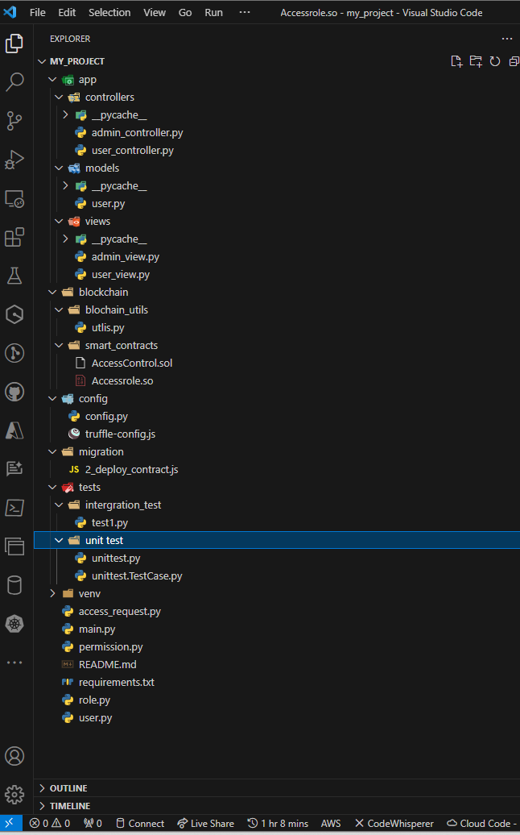

Figure 1:Source Code flow

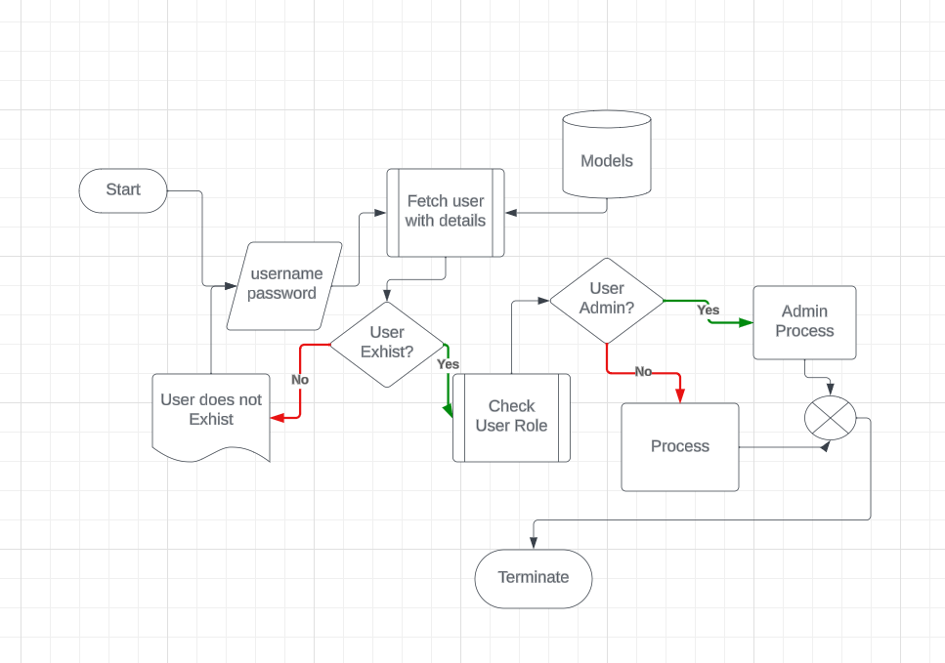

Figure 2: Program flowchart

# Section 4: System Design and Development

## 4.1 RBAC System Design

The designed Role-Based Access Control (RBAC) system, tailored for the Industrial Internet of Things (IIoT), employs a hierarchical architecture to manage access permissions. Central to this architecture are defined roles like 'User', 'Administrator', and 'Device', each associated with specific access rights within the IIoT ecosystem. The system is designed to dynamically assign and revoke roles based on context, such as the user's location, device type, or specific task. This flexibility is crucial in the diverse and dynamic environment of IIoT, where roles and permissions need to adapt to changing conditions and requirements.

## 4.2 Blockchain Integration

Blockchain technology is integrated into the RBAC system to enhance security and provide an immutable audit trail of access control decisions. Each access request and the corresponding decision are recorded as transactions on the blockchain. This integration ensures transparency and non-repudiation, as the records on the blockchain cannot be altered retroactively. The decentralized nature of blockchain also aids in mitigating single points of failure, a critical aspect in the distributed environment of IIoT.

## 4.3 Mathematical Representation of RBAC

The RBAC model is underpinned by mathematical relationships and algorithms that govern role assignments and access control decisions. For instance, the access control decision function can be represented as

*f*(*u*,*o*,*p*)→{*grant*,*deny*}, where �*u* is the user, �*o* is the object (resource), and �*p* is the permission.

# Section 5: Testing, Results, and Evaluation

## 5.1 Testing Methodology

The testing environment simulates an IIoT-enabled smart manufacturing setup. Various scenarios are created to test the system's response to different access requests, including attempts to access resources under varying role assignments and conditions. The blockchain's functionality in recording transactions and maintaining an audit trail is also rigorously tested.

## 5.2 Results

The results demonstrate the system's efficacy in managing access control dynamically and securely. The integration of blockchain showed a marked improvement in the auditability and integrity of access control decisions. Scenarios involving unauthorized access attempts were successfully thwarted, highlighting the robustness of the system.

## 5.3 Evaluation

The evaluation of these results indicates that the proposed RBAC system, augmented with blockchain technology, significantly enhances security in IIoT environments. The system meets the research objectives of providing a flexible, secure, and transparent access control mechanism suitable for smart manufacturing.

# Section 6: Future Work

## 6.1 Potential Enhancements

Future enhancements could include the integration of machine learning algorithms to predict and preemptively address security threats. Additionally, expanding the system to support more complex role hierarchies and incorporating real-time data analytics could further strengthen the system.

## 6.2 Future Research Directions

Further research may explore the scalability of the system in larger, more diverse IIoT networks. Investigating interoperability with other blockchain platforms and extending the model to other domains within the IIoT sphere also present valuable research avenues.

# Section 7: Conclusion

## 7.1 Summary of Findings

This research successfully demonstrates the integration of blockchain technology with RBAC to enhance security in IIoT, particularly in smart manufacturing. The developed system addresses key challenges in access control and establishes a robust framework for managing permissions in a decentralized and dynamic environment.

## 7.2 Implications

The practical implications of this research are significant, offering a viable solution to bolster security in IIoT. Theoretically, it contributes to the evolving discourse on combining traditional security models with emerging technologies like blockchain.

## 7.3 Final Thoughts

The journey of this research highlights the potential of interdisciplinary approaches in addressing complex challenges in the realm of cybersecurity. The findings underscore the importance of continual innovation in the face of rapidly evolving technological landscapes.